7T Detunable Birdcage Manual
Revision A
Version 1
2016 February 1

- Tube Sizing cut cylinders CAREFULLY on tablesaw or ask Simon to do it
  - Cut a 12” cylinder (Birdcage)
    - 41.5 cm in length
  - Cut a 14” cylinder (Shield)
    - 41.5 cm in length
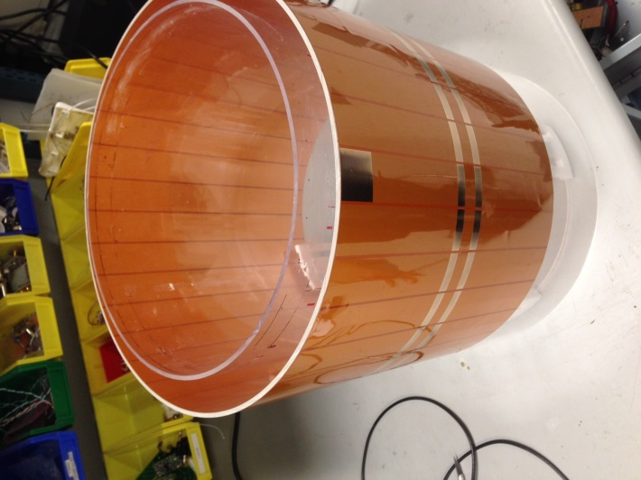

- Copper Layout
- Birdcage (12” cylinder)
- Leave 1 cm of space from the top edge, therefore leaving 12.5 cm from the bottom edge (total length is 28 cm)
- Note: the top edge to the bottom edge of the coil should be around 28cm.
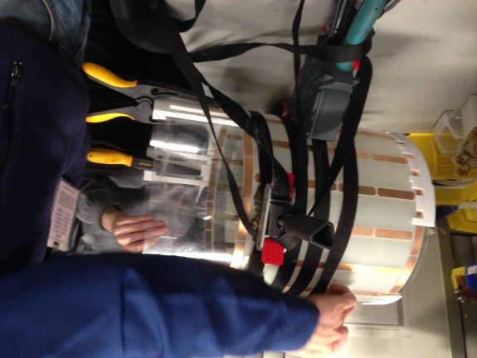
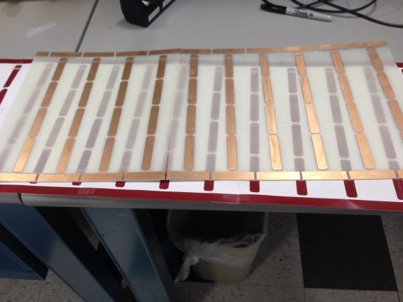
- Use the routed sheets of copper traces to attach to the 12” cylinder with the 1 hour epoxy
- Don’t do it without Cris LaPierre

- Shield (14” cylinder)
- shield 30cm in length -1 cm on the bottom, 1cm on the top (from 28cm birdcage) see photo above

- Capacitors
  - On both end rings use 2.2 pF + 2.7 pF = 4.9 pF total per trace break
  - In the legs use 43 pF + 5.6 pF = 48.6 pF total per trace break → 5 locations

- Tuning
  - Tune the birdcage with the shield in free space using decoupling probes to 297.2 MHz in both quadrature modes. Want a Q ratio (Qunloaded / Qloaded) to be at least 3. We want the coil to be sample (body) noise dominated not coil noise dominated

- Match the coil
  - 5.8 pF → #2 rung
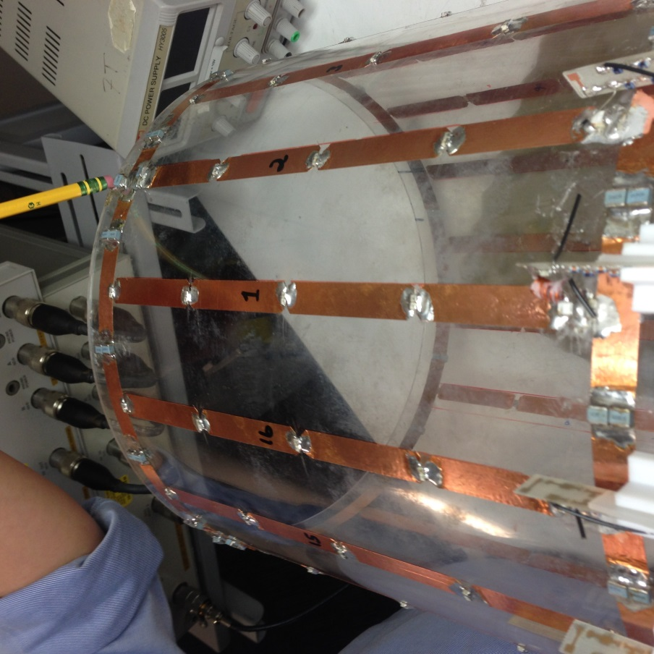
  - 8.2 pF → #14 rung

- Cables
  - RG223 → BNC male
    - Both 115 cm in length
  - RG223 N-type 1 set (for 5A supply)
    - 100 cm in length
    - Note: Measure to 4.5cm and take the black shield cover off, then pull back shield on the cable 3cm

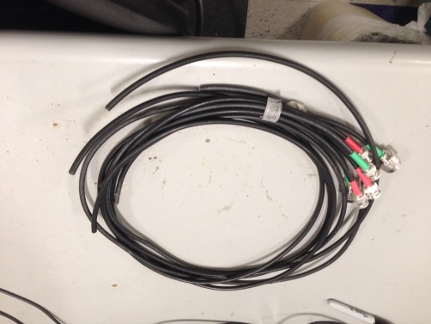

- Connections [what about strain relief?]
  - Connect signal of the cable to match cap
  - Connect ground of the cable on the shield

- Network Analyzer
  - Ensure that there is no coupling between the two quadrature modes. With the decoupling probe measure the frequency of the primary mode in both directions (0th and 90th) tuned to 297.2Mhz
  - Marker = 297.2 MHz
    - S11: -5.7 to -8.2 dB unloaded [is this with the TR switch hybrid?]
    - S22: -5.7 to -8.2 dB unloaded
    - S12 > 25 dB
  - Remove the cables go back in free space mode

- Attaching the “ring” and cables
  - Attach the DC-bias “ring” using hot glue or another similar adhesive
  - Attach the 5A cables
  - Center the cable, here as an example between legs legs #15 and #16. Note: the rings are made to fit this.
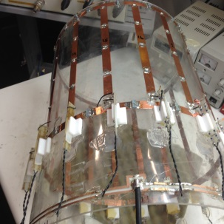
- Building detuning board
  - Bake them in the oven with use of stencil [show photo…]
  - Method of baking detuning board in the oven
    - Use flux on all area
    - Preferably use unleaded solder for safety (tin-silver mixture)
    - Place the chokes and caps in position on the boards.
    - Bake only four boards at one time by placing them in the center of the oven
  - Once baked let them cool and measure the DC resistance in each line in free space
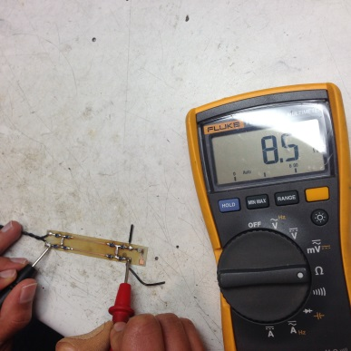
  - 8.5 ohms in each line on the free space as each choke is around 2.2 Ohms in resistance

- 24 AW
  - Twist pair wires and cut 8 cm
  - Cut 1 cm wire which goes to the cathode of the diode
  - Cut 2.5cm wire which goes to the anode of the diode
  - Get all 16 boards ready with wipes
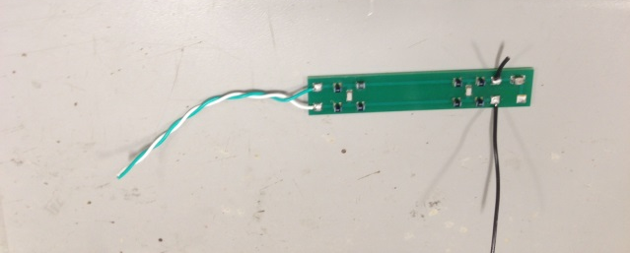
  - Check chokes to re measure the 8.5 ohms in each line
  - Inspect chokes to make sure they are flat against the board

- Placing the detuning boards near the coil.
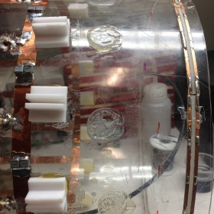
- Position 3D printed “detuning holder” offset from the center of the “big blue cap”

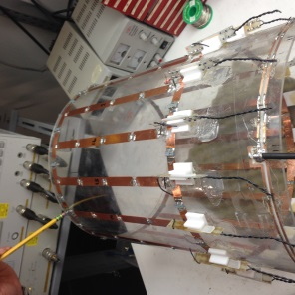
- Before gluing, also place the detuning board in the slot, check
- Solder the diodes as shown in the photo below with the cathode pointing towards the top end of the coil.
- Desolder caps to open the top-piece of connection for the detuning-inductor to be adjusted
- Take caps off by pushing them to the side while you are tuning the inductor
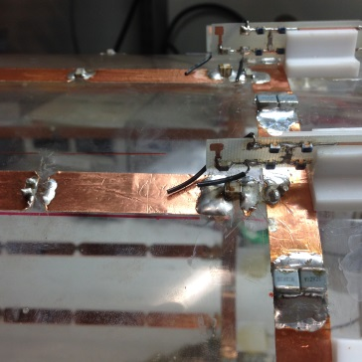

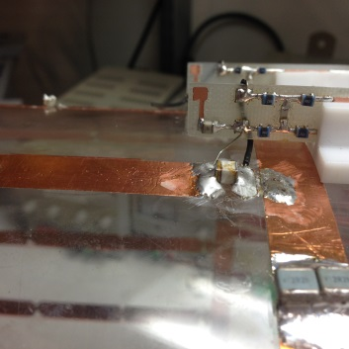
- Place all 16-boards in position and solder the wires

- Hand Wounding the inductor with #23 drill bit and with 7 turns

- Tuning the LC circuit on the detuning board
- Parallel LC circuit
- When diode is off it still has some RF characteristics (some capacitance)
- High impedance, in a parallel LC circuit (between the inductor in parallel with the capacitance across the diode) which creates an additional block across the diode when off during receive to prevent interaction between the transmit and receive coil.
- The inductor is adjusted with the help of a sniffer probe placed close to the inductor turns
  - Look for small notch in S11 of the sniffer probe near the inductor, lightly coupled
- S11 measurement with the notch at 297.2Mhz
- Adjust all 16 inductors this way

- Connecting detuning board to the rung using the twisted pair
- Outside-outside- gnd-ground
- Inside-inside- pwr-power
- Both outside to outside and inside and inside should measure 8.5 ohms
- Make sure to test this
- Make sure they are not shorting
- Testing again with the choke test
- Resolder the caps back into place in each rung
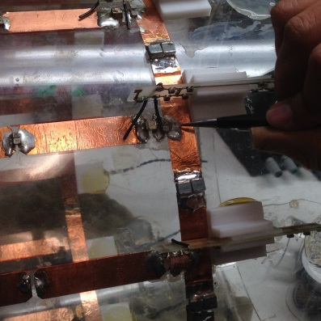

- Rechecking the coil in free space again
- Run the current with a 5A DC power supply
- Measure 0.8V across the diodes that are on now. When a diode is off it should be an open.
- Sometimes if one of the 16 diodes connected in parallel are not functioning there will be some resistance across the diode when turned off
- Also, check the voltage on each of the lines
  - For reference the voltage measured in the power line reads around 2.4V for your reference and the same in the ground line as well
- Place the shield around the coil

- Set the Network Anaylzer for an S21 measurement now with the diodes turned on.
- In free space with the decoupling probe it should be nearly the same as before with the two modes at 297.2Mhz.

- Soldering the cables back and repeat steps 6, 7, and 8 to get nearly the same S parameters again.

- Coil is ready to be checked in the scanner!

Note:
0th mode- -58 dB
90th mode- -61 dB
Should be a 2-3 dB decrease at 7T but we are not sure why

Adjust the double probe so that dip at 297.2 MHz is -70dB is at the marker frequency
May have to adjust the current going to the detuning board to reach 5A

Bandpass birdcage
Primary mode does not want to go to zero but the other modes will
Watch out for: the other modes not going to 0
Also the primary mode going to zero or looking “bumpy” means trouble
Keep checking the chokes resistance in the detuning boards on the power and the ground line again and again.

